# Rotating Horizontal Brush design

We can use a pulley system on top of the panel which can be controlled with the help of DC Motor. This pulley system can pull the rotating brush up and down while it is rotating with the help of DC Motor. And Clean the Panel without using water or any Solution.

Use only deionized Solution for cleaning

Lubricant manufacturer Polywater produces a Solar Panel Wash to help water lift off grime without leaving a film behind. SunSystem Technology uses a blend of diluted vinegar and hydrogen peroxide to remove dirt.

Schematic for Circuit of Stepper Motor [(Source](https://www.youtube.com/watch?v=7spK_BkMJys&t=723s))

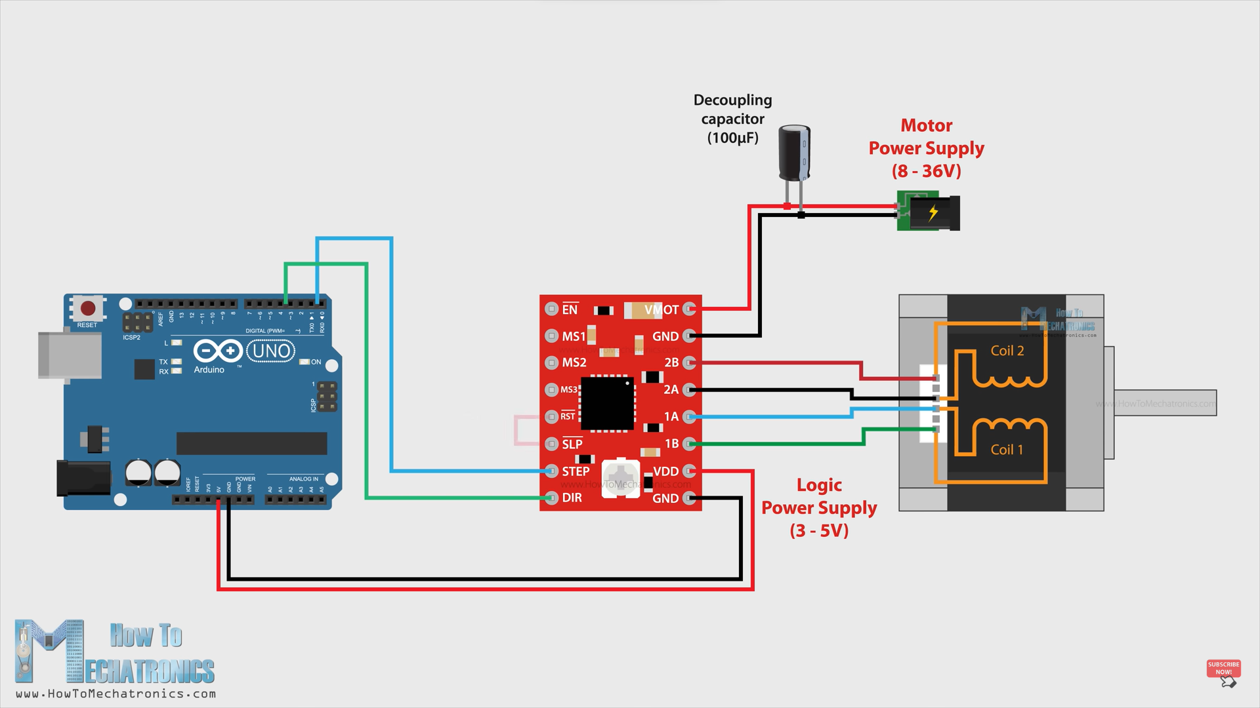

How can we Integrate stepper Motor, driver and Arduino

* Choose a suitable driver which can handle this amount of current.
* Use a Decoupling Capacitor with the power supply to protect he system from Voltage Spikes
* We should use a large electrolytic capacitor with atleast 47 micro Farad capacity.
* 1 Phase of Motor goes to 1A ,1B pins other Phase goes on to 2a 2B pins.
* **How to recognize which two wire of motor would make a phase ?**
  + Rotate the shaft of the stepper motor by hand and connect the two wires to each other. If you connect two wires that make a phae the rotation of the shaft will be a bit mor difficult.
* Step and direction in which can be connected to any pin of the adruino board
* Connect the reset and Sleep pin to each other to have the board enabled
* There is a small trimmer Potentiometer on the a-4988 driver through which we can adjust the current limit and vice versa.By rotating the potentiometer clockwise and the current rises.
* **How can we measure the current Limit ?**
  + Measuring the reference Voltage across the potentiomeer Itself and ground.
  + We can measure the reference Voltage by which we can get current Limit = Vref / (8*Rcs)
* We can use accel Stepper Library for the programming part ([link](https://hackaday.io/project/183279-accelstepper-the-missing-manual))

**Weight of System**

Lets say we will use two steel Plates for our system to support the brush

Approximately they can weigh about 300 gram.

We will use wheels (See [this](https://www.amazon.in/RAB-Caster-1-Wheels-Roller-Casters/dp/B09J8V3KKG))

One wheel is 45 g . Lets say we use 4 .

Then total weight of wheels would be 180 g .

Weight of Brush would be 130 g . (See [this](https://www.amazon.ca/Weiler-SSR-1-21-2IN-DIA/dp/B002C4TCEC))

Weight of a Motor would be around 300 g .

Adding 100 g for any errors.

Total Weight of System would come out to be approximately 1 Kg. (Guessed on Upper side).

Nema 17 stepper Motor with holding torque capacity of 1.5 kg and 4.2 kg cm cost the same . Also Stepper Motor of 5.5 kg cm holding torque comes around the same price.

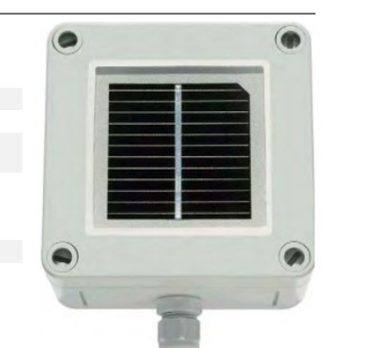

This is the Irradiance Sensor Joy sir was showing me.

So we have chosen 5.6 kg cm cm with stepper Motor .

Which requires a current of 1.2 A . This will come for the Driver .

Precautions :-

A driver should not be given power If it is not connected with stepper Motor. It risks being burnt fast.

A driver potentiometer should be set to 0 amps . Turn the screw clockwise until it bottoms out.

Then connect the system use a potentiometer till the current reaches half of allowed Current.

Start of Design

1. Red and Blue wire are in Phase of Stepper Motor(A)
2. Green and Black wire are in Phase of Stepper Motor (B)
3. Our Motor has 200 Steps or 1.8 degree per Step
4. We will use a 47 u F Decoupling Capacitor with the Power Supply .

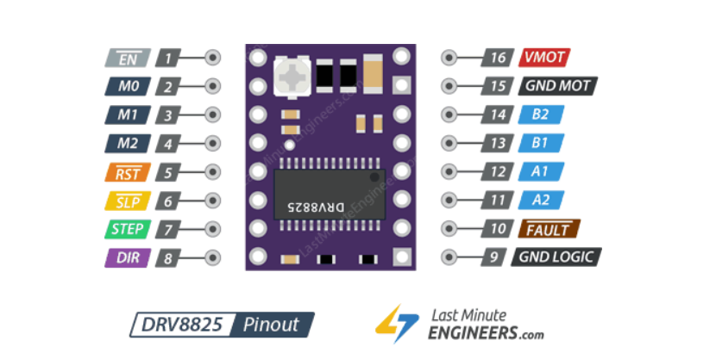

I ran in problem with Power Supply Input . The Power Supply I was using burnt my bread board. I couldn’t figure out the problem. I showed my circuit to endra Sir . He has told me to make the circuit again and get it checked before powering it on.

|  |  |  |  |
| --- | --- | --- | --- |
| Problem | Probable Cause | Potential Solution | Solution Tried |
| Power Supply or Wiring | Loose wires faulty connection | Check Wires and see connection Schematic | Double Checked Connections with more focus on motor wiring Phase . |
| Driver is Faulty | Driver might not be sending signals correctly | Check potentiometer see if there is any abnormal spike in Voltage or run the new system with a new driver to see wether the driver was problem. | Checked with a multimeter waiting for the new driver |
| Mechannical Obstruction | Not Possible no obstruction Visible to naked eyes. | NA | NA |
| Faulty Motor | Motor shaft has disconnected from the coils. | Replace it with a new motor or open it and check for faults | Trying to replace it with a new motor |

DC motor + Driver :-

Required Connection to run the motor with Arduino via UART

1. Connect ground of the driver to ground of the arduino
2. TXD pin of driver with Digital 10 pin of arduino
3. RXD pin of driver with Digital 11 pin of arduino .
4. Use Software Serial Library

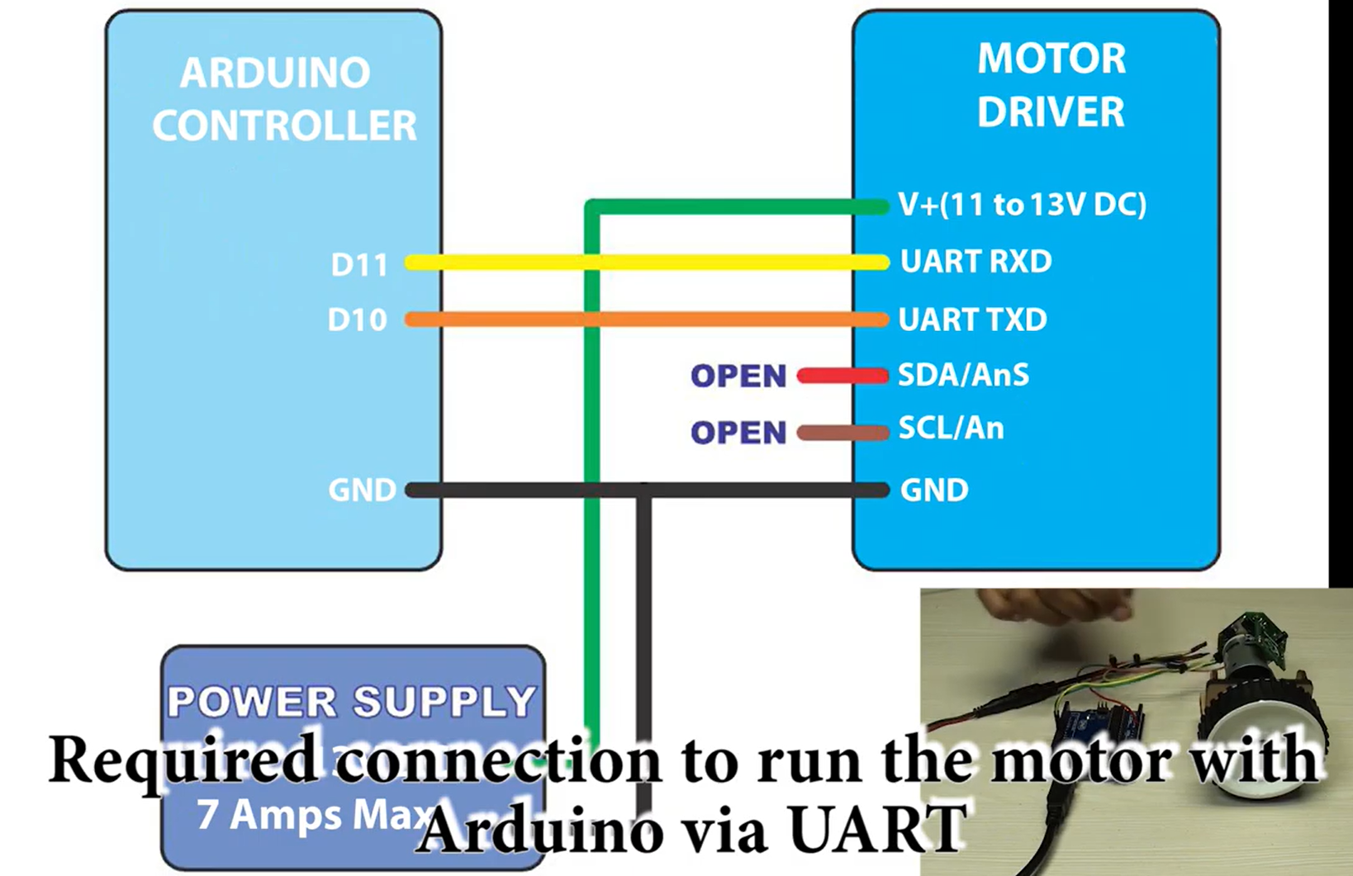

New Stepper Motor

Red and Blue are in Phase

Black and green are in Phase

Testing of Stepper Motor